2018 CIS ANNUAL EDUCATIONAL CONFERENCE SCHEDULE
Sept 24-27, 2018
TIME | MONDAY | TUESDAY | WEDNESDAY | THURSDAY
0800-0930 | Opening Ceremony | Scheduled Workshops  Vendor Hall 0800-1600 | Scheduled Workshops  Vendor Hall 0800-1600 | " Investigating the Mail Bomber - Winnipeg 2015 "  Winnipeg City Police  0800-1100
 | Dr. Brian Donohue "The latest developments in forensic identification at Laurentian University"
0930-1000 hours Break
1000 – 1200 | Paul Isaak Humanizing the Science  1000-1030  RCMP  Case Study TBA  1030-1200 | Workshops | Workshops | Cont...  From Missing to Murdered The Chad Davis Investigation  RCMP  1115-1200
1200-1300 hours Lunch
1300 – 1415 | Cindi R. Corbett, Ph.D.  National Microbiology Laboratory | Workshops | Workshops | Chad Davis File Cont..  1415 hours.
1415 - 1445 hours Break
1445 – 1600 | Richa Mukhra -Ph.D  Research Scholar  Panjab University Department of Anthropology "Footprint Analysis" | Workshops | Workshops | Safe Travels
1800-2000 |  |  | Banquet

Banquet

Tuesday September 25th, 2018

National Microbiology Lab 0830-1130

Lab Tour "Off Site"

Cont...
Wade Knaap

McGyver Forensics "Taking the Lab to the Field"

Cont...

The Use of 3D Laser Scanners in Bloodstain Pattern Analysis

Sgt. Mike Dubyk RCMP

Insp. Chris Puhach

Cops & Kaizens

Burntwood River Project
OFC
Fire Investigator- Tyson Morris

Fire Investigation "What you need to know"

CM Lindsay Scott
and Sgt. Hollie Maffenbeier
Dean Dahlstrom
Chief Firearms Officer

Gunshot Damage Close Vs. Long Range
1230 departure "Police Only"
WPS Wyper Range

Cpl. Jack NERI, MOM, B.FI
POST DISASTER / DISASTER VICTIM IDENTIFICATION (DVI) - FIELD EXERCISE & BEST PRACTICES

Cont...

Cont...

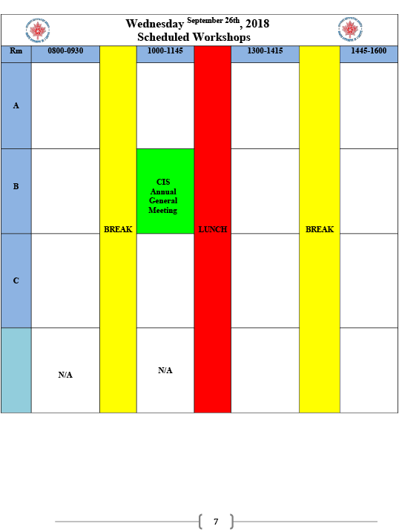

7

Wednesday September 26th, 2018

Expert Fingerprint Testimony Post-PCAST -
Addressing the `1 in 18' Error Rate Myth
Della Wilkinson

Dr. John Younes Manitoba Chief Medical Examiner

Investigation of Fire:
A Case Study

3D Laser Scanning
Sgt. Brian Harder and
Cst. George Kullman

3D Continued

Cpl. Vanessa Philpott
Dorsal Hand Comparison
Wade Knaap

OFC
Fire Investigator Craig Knight

Fire Investigation- "What you need to know"

Developing latent prints on firearms, cartridges and cases:
Does anything really work?

Cont....

Barefoot Morphology-

An Aid To Criminal Investigations

Shelly Massey RCMP

Cont....
Dr. Emily Holland Forensic Anthropology

University of Brandon

Cont...

Res
et

N/A

CIS Annual General Meeting
N/A
N/A

